Java control statement->

if-else->same as c++;

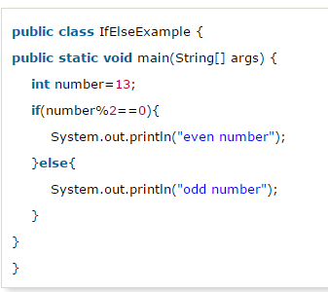

Same as c++

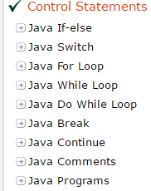

For each->

For array

For(i:arr)

{//code execute

}

1. **public** **class** ForEachExample {
2. **public** **static** **void** main(String[] args) {
3. **int** arr[]={12,23,44,56,78};
4. **for**(**int** i:arr){
5. System.out.println(i);
6. }
7. }
8. }

Output->array print.

If we do simply print the object reference then reference id will print;

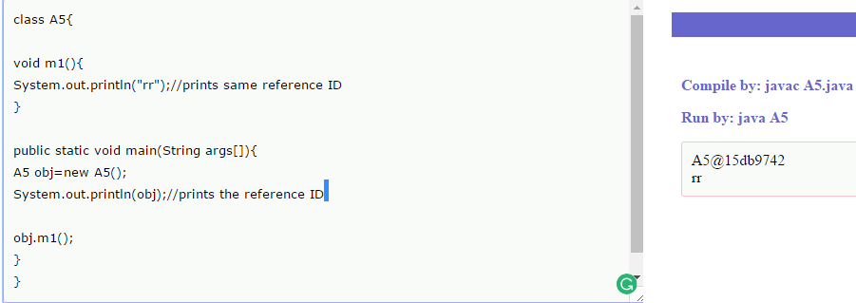

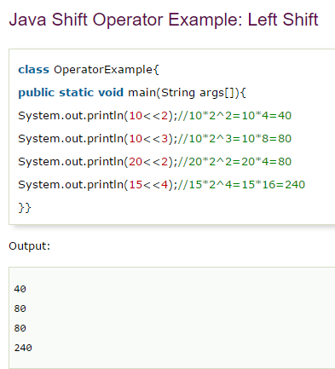

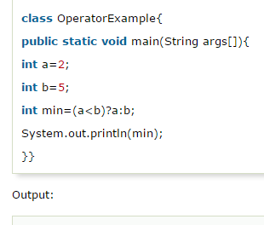

True-a;false b

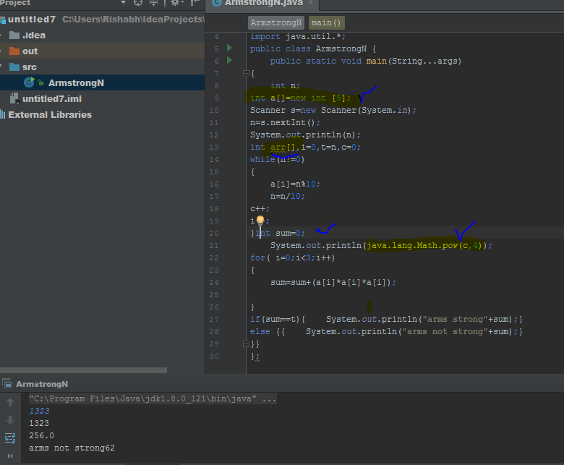

What is the uses of == and .equals

.eqauls for objects refrences and== for values;

If we try == in object and the values of objects are same then it returns false becuz they point to same refrence……

1.in genral == operator ment for refrence(addresss comparison) where as .equls method for content comparison.

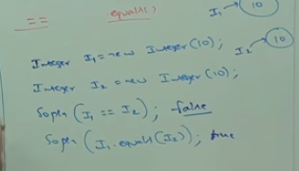

CONVERT INT INTO STRING->

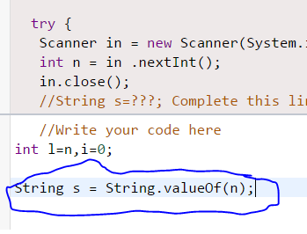

Or int n=43254;

String s=””+n;



Now there many inibuilt function for mislleneous things like

->data func;currency func;